Abstract:
Peripheral nerve injuries can be devastating and result in significant loss of motor and sensory function. One option for nerve repair includes bridging the gap with a synthetic hollow conduit; however due to lack of internal structure these conduits have inferior outcomes. A 3-D printed nerve conduit could mimic the internal fascicular structure of a damaged nerve and may have better outcomes by providing more guidance for nerve regeneration. Our purpose is to test whether nerve reinnervation is improved by using a 3D printed conduit with an internal fascicular structure compared to a hollow conduit in a rat sciatic nerve model.

Statement of clinical relevance:
Almost 3% of patients presenting to a level 1 trauma center were found to have peripheral nerve injuries ranging from neurapraxia to complete transection (1). Approximately $150 billion is spent annually in the U.S. for healthcare associated with nerve injuries (2). Societal costs of such injuries are high; one study estimated $33,000 and $55,000 in total economic loss from ulnar and median nerve injuries respectively (3). Peripheral nerve injury can also have a substantial clinical impact on a patient’s quality of life, ranging from loss of motor function to complete paralysis of a limb. Improvements in upper extremity function obtained via nerve repair may have significant functional benefits for patients, and almost 70% of patients treated surgically for brachial plexus injuries reported motor and sensory improvement within 1 year (4). It is clear that good options for nerve repair are needed to minimize disability and morbidity after nerve injury. We hypothesize that 3-D printed conduits made of a biocompatible acrylate based resin(25) will provide better structural support for regenerating axons. If this is successful, we can use this model for eventual clinical application to restore function after peripheral nerve injury.

- SPECIFIC AIMS

Peripheral nerve injuries are devastating and can result in significant loss of motor function and/or sensation. Such injuries often result in a segmental defect which must be bridged in a manner that minimizes tension, encourages axonal growth and promotes angiogenesis. However, there is no ideal solution to repair of these defects; currently they are bridged using autografts, allografts, and synthetic conduits. Autografts result in superior recovery, but have a limited supply and result in donor site morbidity and longer operative times. Allografts are an alternative treatment measure, but they require either lifelong immune suppression or removal of immunogenic factors from the graft. Either way, the internal architecture is a poor match to the proximal and distal nerve stumps. An alternative solution is a synthetic conduit. Current commercially available nerve guidance conduits consist of a simple cylindrical ultrastructure which has been shown to enhance short gap repair. However, due to their lack of internal architecture, outcomes are generally regarded as inferior compared to grafts. No conduit design has been able to mimic the fascicular topography of the nerve’s internal microstructure. Thus, a critical need exists to create conduits that better align with an injured nerve’s internal architecture.
The long term goal of our lab is to develop a method to produce custom 3-D printed nerve conduits matching the fascicular structure of an injured nerve and incorporating a patient’s autologous Schwann cells. To this end, our lab has designed a 3-D printed nerve scaffold, constructed by rendering serial histological sections from a rat sciatic nerve into 3-D models. To achieve this, we have partnered with a company, Nanoscribe, capable of nanoscale resolution in 3-D printing to print nerve conduits. The objective of this application is to examine the effect of using a custom 3-D printed nerve scaffold versus a standard cylindrical single-channel scaffold on axonal regeneration in an animal model. Our central hypothesis is that utilization of a custom 3-D printed nerve scaffold will result in increased axonal regeneration and better functional outcomes compared to standard nerve scaffolds. This hypothesis is based on a careful review of the available literature and our own clinical and experimental observations. The rationale for this work is that an internal architecture within the conduit will provide better structural support for the regenerating axons and can provide a future substrate for application of autologous Schwann cells through pores within the conduit. To attain these objectives we will utilize a rat sciatic nerve injury model and accomplish the following specific aim:

Aim 1: Quantify the difference in functional and histological outcomes of axonal regeneration in a rat sciatic nerve model after transection and repair with a custom 3-D printed nerve conduit compared to a hollow tube conduit. Our working hypothesis is that a scaffold design that maximizes interior volume and accurately directs fascicle bundles across a nerve injury gap will outperform the current standard of care conduit as measured by muscle force testing, walking track analysis, and histomorphometry.

The expected outcome of the proposed work is a better understanding of the effect of internal neuronal architecture on axonal regeneration. Regeneration of peripheral nerves over a long gap (> 6 cm) remains an unsolved problem in hand and microsurgery - autografts, allografts, and conduits all demonstrate incomplete recovery after neurotmetic injury. By recreating the fascicular topography of a segmental defect, we hope to improve on current techniques and provide a possible template for additional work in regenerative medicine. Refinement of this 3-D printing model could lead to future development of 3-D printed nerve grafts seeded with Schwann cells and neurotrophic factors for direct clinical application in patients with peripheral nerve injury.
RESEARCH STRATEGY
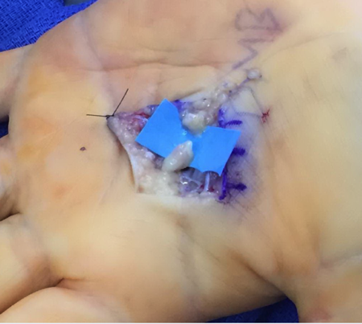
B. Significance
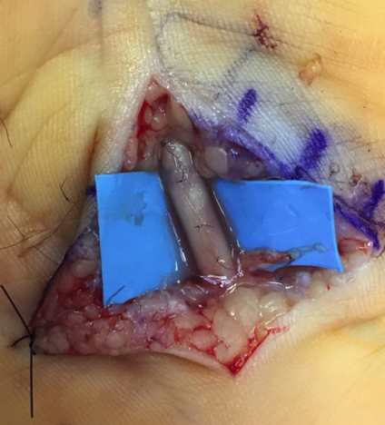
B.1 Regeneration of peripheral nerves over long gap remains an unsolved problem in hand and microsurgery. When nerves are damaged or transected, primary repair is often impossible due to a wide zone of injury in the nerve. Repair of damaged nerve tissue ends to one another leads to universally poor outcomes (5), thus the damaged tissue must be resected and the resulting gap reconstructed. The reconstructive options available to a surgeon include autograft sensory nerve harvested from healthy limbs, frozen decellularized allograft, or hollow channel commercially prepared nerve conduits – all of these result in significant axonal loss across the spanned defect. The goal of this pilot research study is to test a novel nerve conduit that promotes better cell attachment and migration in order to improve regeneration across a critical-size segmental nerve defect. When a nerve is severed, the reparative process begins with the formation of a fibrin clot along which the nerve eventually rebuilds. Fluid within the space between the two cut ends becomes populated with supportive cells and eventually collagen-coated myelinated fibers bridge the gap (7). Current commercially available conduits consist of a biocompatible cylindrical ultrastructure with no internal architecture, these provide limited guidance to developing neotissue allowing regeneration to occur over only relatively short distances (usually less than 1 to 2 cm) (6). Regeneration of peripheral nerves over long gaps remains an unsolved problem in hand and microsurgery with autografts, allografts, and conduits all having been shown to be sub-optimal.
Figure 1: Nerve defect after exploration for a sharp transection.

B.2 Autografts remain the gold standard but impart some additional morbidity to the patient, including loss of sensation in the sensory distribution of the harvested nerve. Autografts also typically result in a size mismatch, as small sensory nerves are harvested (usually sural nerve) and used to reconstruct major mixed peripheral nerves. This requires the smaller sural nerve to be sectioned to the appropriate defect length and combined in a cable grafting technique. Harvesting of the autograft results in additional morbidity to the uninjured leg, increases operative costs and time, and can lead to complications such as numbness, pain, and cold intolerance (8).
Figure 2: Nerve defect bridged by a synthetic conduit

B.3 An ideal solution would provide a synthetic product that enhances peripheral nerve repair by recapitulating the benefits of an autograft with additional signaling characteristics to aid neuronal regeneration. An ideal synthetic graft would alleviate the morbidity of autografts and speed up operative times by foregoing additional donor nerve harvesting and preparation. Currently, decellularized allografts are available and provide a scaffolding along which the nerve can regenerate. However, these are expensive to procure and must be kept in proper cold storage until use. Additionally, allografts only provide a scaffold for the nerve to grow through without any additional molecular or cellular signaling to properly facilitate nerve recovery. Allografts also have the potential to induce undesirable immune responses and carry infection risks (9).

B.4 Current synthetic condutis remain an inferior alternative to autografts and allografts. Current commercially available nerve guidance conduits consist of a simple cylindrical ultrastructure which has been shown to enhance short gap repair as seen in Figures 1 and 2 (10). Unfortunately, the lack of an internal structure within these conduits provides minimal directional guidance for developing neotissue limiting their capacity to facilitate large gap repair (11). Recent research has focused on improving the performance of nerve guidance conduits for segmental defect repair through the use of multiple internal longitudinal channels (12). This method has shown promise, but has yet to yield products that can adequately repair segmental nerve defects. A possible reason for the sub-optimal performance of these engineered systems is that they lack the resolution to mimic the internal fascicular architecture necessary to promote large gap nerve repair.

C. Innovation
Recent research has focused on the design of conduits with desirable internal structure to facilitate larger nerve gap regeneration. Yao et al. examined the influence of multiple conduit channels on nerve regeneration and found that the inclusion of several smaller channels limited directionally-incorrect axon dispersion without compromising regeneration (13). Other groups have utilized etched micropatterns in conduits (14) as well as electrospun nanofibers to influence longitudinal growth of neurons along the intended axis (15). These results suggest that structural guidance helps to improve regenerate nerve alignment resulting in greater axon number, axon diameter, and higher electrophysiologic amplitudes (15).

The proposed work seeks to challenge the conventional paradigm of utilizing hollow conduits for nerve repair. By increasing the surface area for attachment of fibroblasts and Schwann cells, this technology could potentially enhance functional recovery. A synthetic conduit created with 3-D printing allows customization of the shape and architecture which may help to guide axonal regeneration and eventually allow for seeding of the conduit with molecules capable of promoting nerve regeneration.

Development of a printable conduit model has profound implications even beyond the scope of the current work. Peripheral nerves are divided into compartments of grouped fascicles. The internal topography of various peripheral nerves has been described at different levels of the forearm and arm, facilitating more precise grouped fascicular repair intraoperatively (16). This type of repair (groups of fascicles to matched groups of fascicles) potentially leads to improved recovery as fewer axons are lost to aberrant paths during regeneration. Current conduit-based repair techniques forego the potential advantage of grouped fascicular repair as there is no structural guidance to facilitate such end-to-end alignment.

Nanoscribe (Nanoscribe GmbH, Eggenstein-Leopolds-hafen, Germany) is a biotech company that is able to 3-D print biocompatible nerve conduits based on computer models of peripheral nerves. Nanoscribe utilizes a Photonic Professional GT2 3-D printer to create fully customizable biocompatible 3D printed scaffolds. The 3-D printer allows them to print with submicron precision necessary to mimic the fascicular topography of something as small as a rat’s sciatic nerve. This is accomplished using maskless lithography technology which uses nonlinear light absorption to trigger a depolymerization of material that can be washed away in a developer bath, thus creating the 3D printed conduit.

Future work will include the development of 3-D computer models of major peripheral nerves throughout the upper and lower extremities from digital scanning of histologic sections. These could then be readily adapted to allow custom 3-D printed nerve grafts which may eventually be seeded with neurotrophic factors, nanoparticles, or Schwann cells to enhance regeneration. These advancements may eventually allow surgeons to move beyond the sub-par results seen with the use of autologous cable grafts, the current gold standard of care.

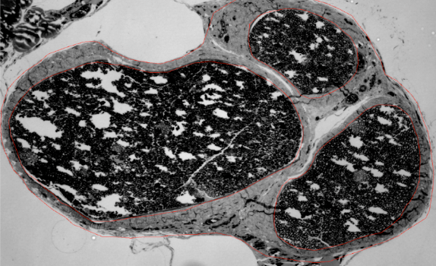
D. Preliminary Data:
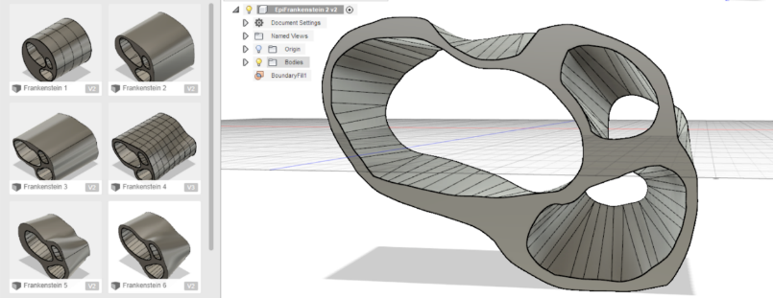
D.1 Rat Sciatic Nerve Fascicular Mapping: We have completed a study to acquire preliminary data for the proposed research plan. Our lab has mapped the internal fascicular topography of a rat sciatic nerve and created a 3-D model of this nerve suitable for 3-D printing (the entire described protocol can be found in Appendix 1). We were able to accomplish this by taking a 1cm section of a rat sciatic nerve and cutting it along the length of the nerve in 1mm intervals. These sections were then made into histology slides (as seen in Figure 3) to depict the structure of the nerve fascicles. The sections were then used to create a 3-D model of the rat sciatic nerve seen in Figure 4 with various computer programs (Clemex Image Analysis software, Free-D, MeshLab and Autodesk Fusion 360).
Figure 3: Sectioned rat sciatic nerve illustrating grouped fascicles

D.2 3-D Printing of Rat Sciatic Nerve Conduits: The previously described rat sciatic nerve model will be sent to Nanoscribe (Nanoscribe GmbH, Eggenstein-Leopolds-hafen, Germany) for 3-D printing of nerve conduits to precisely match the topography of our proposed experimental defect. Nanoscribe will also print the standard of care hollow cylindrical conduits to be used as a control out of the same biocompatible acrylate based resin which has previously been used in animal models (25). After the conduits are printed they will be sent to our laboratory for implantation.
Figure 4: Example of 3-D nerve model for conduit design

E. Experimental design
E.1 Survival surgery: A total of 20 Lewis rats will be divided into 2 separate groups of 10 each, each group will undergo an initial survival surgery to induce a sciatic nerve injury by resecting 1cm of sciatic nerve. Table 1 details the control and experimental groups. The defect will be bridged with either the standard of care hollow tube conduit or a 3D printed conduit which will be provided by Nanoscribe after printing as described above. During the initial procedure, inhaled isoflurane delivered through a nosecone will be utilized to ensure appropriate anesthesia with buprenorphine given as an analgesic. A trans-gluteal approach to the sciatic nerve will be made. A 10 mm segment of nerve centered 8 mm proximal to the trifurcation will be excised. Each cut end of the remaining nerve will then be sutured to the free end of one of the two types of conduits described above. This will be accomplished with 9-0 nylon utilizing standard microsurgical techniques and epineurial sutures. The skin will then be closed with absorbable suture and the animals allowed activity ad libitum until the non-survival procedure 6 weeks later. The P.I. (P.C.) will be responsible for the initial survival rat surgeries and implantation of the nerve conduits.

E.2 Non-survival surgery: At 6 weeks after the initial survival surgery each animal will undergo a walking track test to measure the sciatic functional index detailed in E.4 (18) followed by a non-survival surgery. The 6 week interval has previously been shown to be adquate time for nerve regneration and functional recovery in Lewis rats ( ).The animals will then be anesthetized using standard techniques and the previous wound re-opened. Electrodiagnostic studies will be performed and the tibialis anterior and gastrocnemius maximum isometric tetanic force will be measured, as detailed in E.3. The repaired nerve will also be harvested and a histologic section prepared from a sample taken 3 mm distal to the end of the conduit. This will then be prepared by a labrotory technician according to a previously published protocol and analyzed by the same technician with a semi-automated system to evaluate axon count, diameter, and myelin width detailed by E.5 (19). The first male and female rats tested from each group will also have the contralateral, healthy sciatic nerve harvested for comparison. The rats will then be euthanized with CO2 inhalation. The P.I. will be responsible for the walking track test, non-survival rat surgeries, electrodiagnostic studies, and harvesting the sciatic nerves bridged by conduits. Dr. Brogan’s laboratory techinician (trained in nerve histomorophologic analysis) will be responsible for completing this analysis.

Table 1:
Group | Group  Description | Treatment | N
IA | 3D Printed Conduit | Sciatic Nerve Repaired with 3D Printed Conduit | 10
IB | Standard Hollow Conduit | Sciatic Nerve Repaired with Standard Hollow Conduit | 10

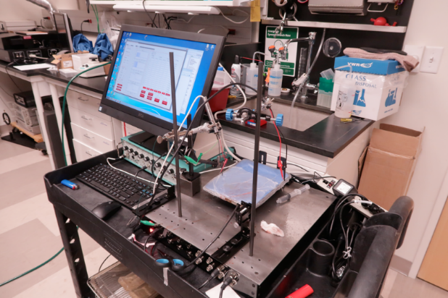
E.3 Electrodiagnostic studies: Our lab has acquired a custom built small animal functional assessment system designed by Red Rock Laboratories to perform nerve conduction and electromyographic studies to quantify the muscle force of muscles innervated by branches of the sciatic nerve. The tibialis anterior and gastrocnemius maximum isometric tetanic force will be measured utilizing a custom built force transducer (20) (Figure 5).

E.4 Walking Track Analysis Just prior to the non-survival surgery, we will perform a walking track analysis on each rat which allows us to quantify sciatic nerve function (12,13,14). The hindlimb paws will be painted with India ink and the rat placed into a custom apparatus with a narrow corridor and an opening at one end as seen in Figure 6. Pawprints will be recorded on white paper and a digital photograph taken. The Sciatic Function Index (SFI) (Figure 8) will be calculated with the Image J software(12) according to previously described methods (26,27,28) using the formula: 𝑆𝐹𝐼 = −38.3∗(𝐸𝑃𝐿−𝑁𝑃𝐿)/𝑁𝑃𝐿 + 109.5 ∗(𝐸𝑇𝑆−𝑁𝑇𝑆)/𝑁𝑇𝑆+13.3 ∗ (𝐸𝐼𝑇−𝑁𝐼𝑇)/𝑁𝐼𝑇) – 8.8. Two trials of the walking track analysis will be performed for each rat and the average SFI recorded.
Figure 5: Schematic of a custom built force transducer to measure tib. ant and gastric force
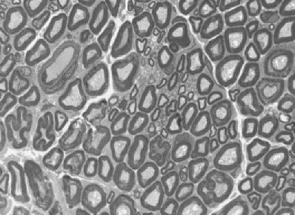
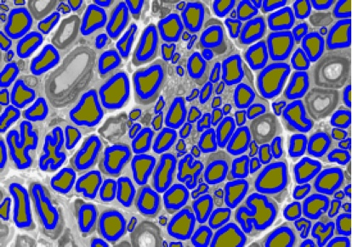
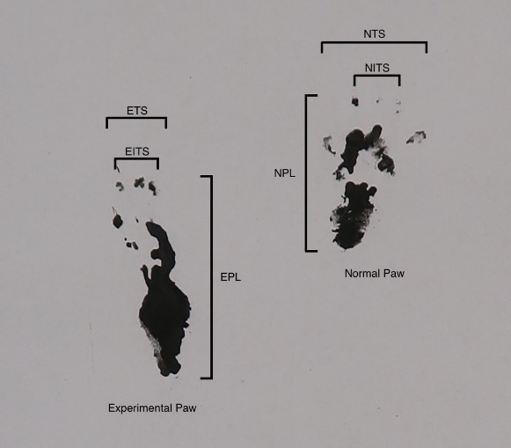
E.5 Histologic Analysis: A histologic section 3 mm distal to the end of the conduit will be harvested at the conclusion of the non-survival surgery. Each specimen will be fixed in 3% EM grade glutaraldehyde, postfixed with 1% osmium tetroxide and dehydrated in ethanol. The tissue will then be embedded in Araldite 502 with subsequent sectioning on the ultramicrotome into ultrathin slices, per a previously published protocol (17). Slides will be examined with an Olympus Bx-40 microscope with a mounted digital camera and 100x oil immersion lens. Photomicrographs will be obtained and analyzed with a custom binary imaging algorithm developed by Hunter et al (17) that performs semi-automated detection of nerve fibers (Figure 7). Histological outcomes will include (1) axonal count, (2) ratio of axon to myelin circumference (G-ratio),(3) and axon diameter as a percentage of the histological controls. Histological analysis will be performed in the Nerve Research Laboratory at Washington University in St. Louis by an experienced research technician (JW). Our technician has extensive experience in histology and was trained by Daniel Hunter to perform the semi-automated binary imaging histomorphometric analysis that Hunter developed and previously published (17).
Figure 6: Walking track analysis example
Figure 7: A) Photomicrograph of rat sciatic nerve after fixing with osmium tetroxide and sectioning; B) Semi-automated histologic identification of axons and their surrounding myelin (shown in blue).

B
A

F. Statistical Analysis
Percentage of axons and diameter of axons in each regenerate will be compared among the groups utilizing a Kruskal-Wallis test for non-parametric distributions. A power analysis was conducted utilizing data from a similar protocol evaluating nerve regeneration in a rat model. The primary outcome measure will be axon count. Using Isaac’s (21) data for axon caliber in a rat sciatic nerve repair model, axon caliber in a reverse autograft group was 2.397+/- 0.2552 while the caliber in a group repaired with a well matched conduit had an axon caliber of 2.807 +/- 0.29. To detect a significant difference between groups using a 1-way ANOVA with a 95% confidence interval and power = 0.80, 8 rats would be needed in each group. Therefore, to account for the possibility of intra-operative mortality or post-operative autotomy requiring euthanasia, 10 rats were deemed to be an appropriate sample size for each group.

G. Protection of Human Subjects / Vertebrate Animals
A total of 20 adult male Lewis rats will be used for this study. These will be divided into 2 groups of 10 each. The number required in each group is based on a power analysis (see above), with 2 additional rats in each group to account for potential loss secondary to surgical site infection, peri-operative mortality and autotomy requiring euthanasia. Rats will be housed at the Washington University School of Medicine animal housing. Each animal will undergo an index survival surgery at time 0 and a second non-survival surgery after 6 weeks.
Rats are a common animal model utilized in peripheral nerve research. The length of the sciatic nerve and femoral nerves allow for creation of segmental defects up to 40 mm in length. The diameter of their major peripheral nerves facilitates surgical manipulation and their relatively low cost make them ideal models for early stage investigation of peripheral nerve injury and subsequent repair. Histologically, the rat sciatic nerve is nearly identical to that of a human peripheral nerve (22). Multiple studies have validated the use of a rat model in examining nerve crush injury (23) and segmental defect repair (24).
Intra-operatively 1-5% iso-flurane will be administered continuously via nosecone for the duration of the operation. Sustained release buprenorphine will be administered pre-operatively for pain control. Pain will be assessed by monitoring the vital signs and movements of the subject, with anesthetic dose adjusted to maintain an appropriate level of sedation. Surgery will be performed on a warming blanket to prevent hypothermia. Oral carprofen will be administered post-operatively every 24 hrs for 48 hours to provide effective analgesic control. All surgeries will be performed with aseptic technique, including pre-operative clipping of fur and aseptic preparation of the surgical site.
During the initial survival surgery, a gluteal splitting approach to the sciatic nerve will be performed, exposing the nerve from the sciatic notch to the level of the trifurcation. The nerve will then be transected, with creation of a segmental defect, as per the protocol above, and then repaired with a conduit according to the technique specified by its group. The wound will then be closed with absorbable suture.
Post-operatively, daily care of the animals will be performed by the husbandry staff with assessment daily by study personnel for the first 2 days. Regular monitoring will be conducted by protocol personnel to assess wound healing and look for evidence of post-operative pain. Pain will be managed with appropriate analgesia. Animals will be assessed again at 7 days to monitor for signs of wound dehiscence. If wound dehiscence occurs, animals will be anesthetized again, the wound opened, irrigated and closed again. If they display persistent signs of infection, a veterinarian will be involved in their care to determine further actions, including possible administration of antibiotics or euthanasia. All animals will be monitored on a daily basis by husbandry staff, with ready access to staff veterinarians if needed to ensure their continued well being.
At the end of the study period, a second non-survival surgery will be performed. At the time of that surgery, each animal will undergo a walking track test to measure the sciatic functional index. Each animal’s tibialis anterior and gastrocnemius maximum isometric tetanic force will be measured bilaterally, along with nerve conduction studies and subsequent euthanasia of the animal. Sections of the previously operated on sciatic nerve will then be harvested for analysis, as well as the contralateral sciatic nerve to use as a control. Euthanasia will be performed with CO2 inhalation, and bilateral thoracotomies as a secondary procedure. This is considered an acceptable method of euthanasia by the American Veterinary Medical Association (AVMA) Guidelines on Euthanasia 2013 Edition, as found on pg. 48. This should cause minimal distress and pain to the subject.

Bibliography
1. Noble J, Munro CA, Prasad VS, Midha R. Analysis of upper and lower extremity peripheral nerve injuries in a population of patients with multiple injuries. Journal of Trauma and Acute Care Surgery. 1998;45(1):116-122.
2. Taylor CA, Braza D, Rice JB, Dillingham T. The incidence of peripheral nerve injury in extremity trauma. The American Journal of Physical Medicine and Rehabilitation. 2008;87(5):381–385
3. Rosberg H, Carlsson K, Höjgård S, Lindgren B, Lundborg G, Dahlin L. Injury to the human median and ulnar nerves in the forearm–analysis of costs for treatment and rehabilitation of 69 patients in southern Sweden. Journal of Hand Surgery (British and European Volume). 2005;30(1):35-9.
4. Choi PD, Novak CB, Mackinnon SE, Kline DG. Quality of life and functional outcome following brachial plexus injury. The Journal of hand surgery. 1997;22(4):605-12.
5. Zachary LS, Dellon AL. Progression of the zone of injury in experimental nerve in juries. Microsurgery. 1987;8(4):182-5.
6. Muheremu A, Ao Q. Past, Present, and Future of Nerve Conduits in the Treatment of Peripheral Nerve Injury. BioMed Research International. 2015;2015:237507.
7. Scaravilli F. Regeneration of the perineurium across a surgically induced gap in a nerve encased in a plastic tube. Journal of Anatomy. 1984;139(Pt 3):411-24.
8. Miloro M, Stoner JA. Subjective Outcomes Following Sural Nerve Harvest. Journal of Oral and Maxillofacial Surgery. 2005;63(8):1150-4.
9. Ray, W. Z.; Mackinnon, S. E., Management of nerve gaps: Autografts, allografts, nerve
transfers, and end-to-side neruorrhaphy. Experimental Neurology 2010, 223, (1), 77-85.
10. Muheremu, A.; Ao, Q., Past, present, and future of nerve conduits in the treatment of peripheral nerve injury. BioMed Research International 2015, 2015, 237507.
11. Kehoe, S.; Zhang, X. F.; Boyd, D., FDA approved guidance conduits and wraps for peripheral nerve injury: A review of materials efficacy. Injury 2012, 43, (5), 553-572.
12. Yao, L.; de Ruiter, G. C.; Knight, A. M.; Spinner, R. J.; Yaszemski, M. J.; Windebank, A. J.; Pandit, A., Controlling dispersion of axonal regeneration using a multichannel collagen nerve conduit. Biomaterials 2010, 31, (22), 5789-5797
13. Yao L, de Ruiter GC, Knight AM, Spinner RJ, Yaszemski MJ, Windebank AJ, Pandit A. Controlling dispersion of axonal regeneration using a multichannel collagen nerve conduit. Biomaterials. 2010;31(22):5789-97.
14. Lin Y-L, Jen J-C, Hsu S-h, Chiu M. Sciatic nerve repair by microgrooved nerve conduits made of chitosan-gold nanocomposites. Surgical neurology. 2008;70:S9-S18.
15. Wang W, Itoh S, Konno K, Kikkawa T, Ichinose S, Sakai K, Ohkuma T, Watabe K. Effects of Schwann cell alignment along the oriented electrospun chitosan nanofibers on nerve regeneration. Journal of Biomedical Materials Research Part A. 2009;91A(4):994-1005. doi: 10.1002/jbm.a.32329.
16. Watchmaker GP, Gumucio CA, Crandall RE, Vannier MA, Weeks PM. Fascicular topography of the median nerve: a computer based study to identify branching patterns. The Journal of hand surgery. 1991;16(1):53-9.
17. Hunter, D. A. et al. Binary Imaging Analysis for Comprehensive Quantitative Assessment of Peripheral Nerve. J Neurosci Methods 166, 116–124 (2007).
18. Sarikcioglu L, Demirel B, Utuk A. Walking track analysis: an assessment method for
functional recovery after sciatic nerve injury in the rat. Folia morphologica. 2009;68(1):1-7.
19. Hunter DA, Moradzadeh A, Whitlock EL, Brenner MJ, Myckatyn TM, Wei CH, Tung TH,
Mackinnon SE. Binary imaging analysis for comprehensive quantitative histomorphometry of
peripheral nerve. Journal of neuroscience methods. 2007;166(1):116-24.
20. Shin RH, Vathana T, Giessler GA, Friedrich PF, Bishop AT, Shin AY. Isometric tetanic force
measurement method of the tibialis anterior in the rat. Microsurgery. 2008;28(6):452-7.
21. Isaacs J, Mallu S, Yan W, Little B. Consequences of oversizing: nerve-to-nerve tube
diameter mismatch. The Journal of Bone & Joint Surgery. 2014;96(17):1461-7
22. Mackinnon SE, Hudson AR, Hunter DA. Histologic assessment of nerve regeneration in the
rat. Plastic and reconstructive surgery. 1985;75(3):384-8.
23.Bridge PM, Ball DJ, Mackinnon SE, Nakao Y, Brandt K, Hunter DA, Hertl C. Nerve crush
injuries—a model for axonotmesis. Experimental neurology. 1994;127(2):284-90.
24. Shin RH, Friedrich PF, Crum BA, Bishop AT, Shin AY. Treatment of a segmental nerve
defect in the rat with use of bioabsorbable synthetic nerve conduits: a comparison of
commercially available conduits. The Journal of Bone & Joint Surgery. 2009;91(9):2194-204.
25. Son A, Opfermann, J, McCue C, Ziobro J, Abrahams III J, Jones K, Morton P, Oluigbo C, Krieger A, Liu J, Hashimoto-Torii K, Torii M. An Implantable Micro-Caged Device for Direct Local Delivery of Agents. Sci Rep. 2017;7(1):17624.
26. Schneider CA, Rasband WS, Eliceiri KW. NIH Image to ImageJ: 25 years of image analysis. Nature methods. 2012;9(7):671.
27. Hare G, Evans P, Mackinnon S, Best T, Bain J, Szalai J, Hunter D. Walking track analysis: a long-term assessment of peripheral nerve recovery. Plastic and reconstructive surgery. 1992;89(2):251-8.
28. Sarikcioglu L, Demirel B, Utuk A. Walking track analysis: an assessment method for functional recovery after sciatic nerve injury in the rat. Folia morphologica. 2009;68(1):1-7
29. Brenner M, Moradzadeh A, Myckatyn T, Tung T, Mendez A, Hunter D, Mackinnon S. Role in timin in assessment of nerve regeneration. Microsurgery. 2008;28(4):265-72.
Appendix 1: Protocol used to create a 3-D model of a rat sciatic nerve
A 1.0 cm section of rat sciatic nerve was harvested and fixed overnight in 3% EM grade glutaraldehyde. The samples were post-fixed in 1% osmium tetroxide, dehydrated in graduated ethanol concentrations (50%, 70%, 90%, and 100%), and embedded in Araldite 502 resin (Ted Pella, Redding, CA). An LKB III Ultramicrotome (LKB-Produkter, Sweden) was used to cut a total of ten 1 um-thick cross-sections at 1 mm intervals. Sections were stained with 1% toluidine blue and viewed under light microscopy using an Olympus BX40 light microscope (Olympus, Center Valley, PA).

Using serial histology sections allowed for 3D reconstruction of the nerve structure as seen in Figures 4 and 5. Clemex Image Analysis software (Longueuil, Québec, Canada) has been previously used for quantitative analysis of nerve samples (16). In this case, Clemex was used to capture digital images of the histology sections and to identify and isolate the epineurium and perineurium in each section. The Clemex software gives an output of TIFF images, which were imported into Free-D (Institut Jean-Pierre Bourgin, Versailles, France), a three-dimensional reconstruction software for use with stacks of serial histology sections (17). In Free-D, the serial images form a stack, with a separation of 1.0 mm, a pixel width value obtained from Clemex, and an aspect ratio of 1.0. The “Register” tool was used to align the images, and two models were created with no “begin cap” or “end cap”. One model was used to recreate the internal structure of the scaffold, while the other outlined the epineurium. Finally, the “Reconstruct” function was used to produce a 3D model (Figure 5), which was exported to .STL file format (a format suitable for 3D printing).

The base .STL format was not suitable for use with CAD programs like Autodesk Fusion 360, and so an intermediate step was required to convert the triangle mesh into a quadrangle-dominant mesh. This task was performed by MeshLab: an open-source mesh processing tool. The .STL files were imported to MeshLab, and the “Turn into Quad Dominant Mesh” filter was applied to the model, which was then exported as an object file (.OBJ). The object file (.OBJ) was imported into Autodesk Fusion 360, and converted from a surface mesh to T-Spline using the “Convert” function in the Mesh Workspace. The “AutoRepair” tool was used to make the surface bodies manifold while also further smoothing the scaffold design. The “Boundary Fill” function was used to generate a solid body model of a corresponding nerve scaffold, which was then exported as a .STL file for 3D printing.

