You will need an account in Proposal Central, if you do not already have one, and will need to start the application and give me and Tonia Thompson access. https://proposalcentral.com/

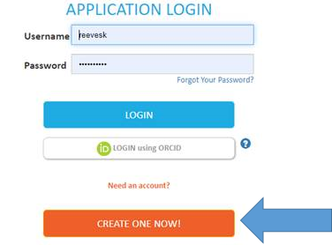

Go to the Grant Opportunities tab, type OREF (or whatever sponsor you plan to apply to) in the search bar, find the opportunity on the list and click Apply Now.
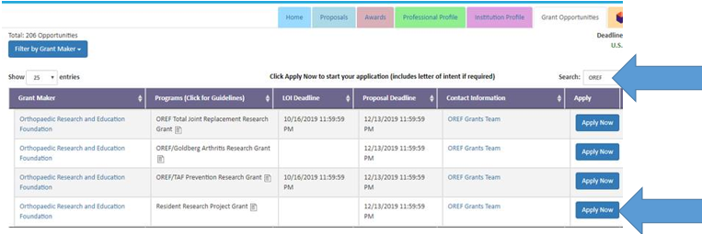

Please grant ADMIN access to Kathy Reeves, Stephanie Simpson and Tonia Thompson and we will complete the administrative pieces for you.
reevesk@wustl.edu , thompsont@wustl.edu and s.simpson @wustl.edu
